LAB NO 01

TASK NO 01:

CREATE LIST USING FOR LOOP:
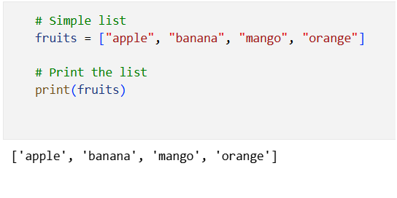
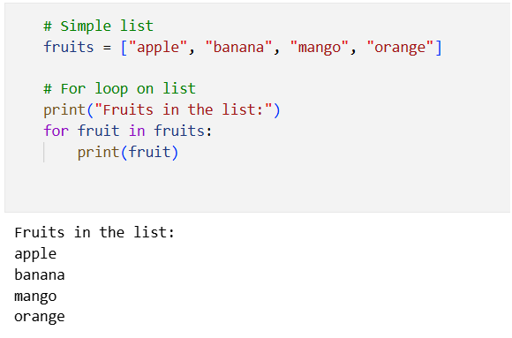

TASK NO 02:

ADDITION:
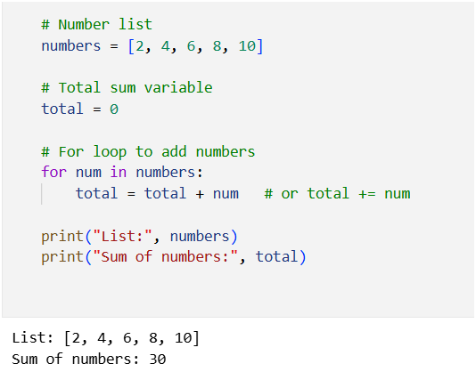

TASK NO 03:

SUBTRACTION:
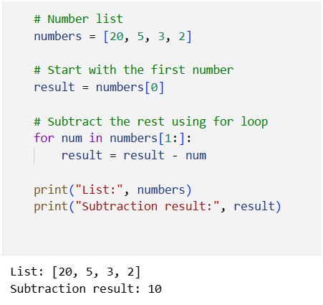

TASK NO 04:

MULTIPLICATION:
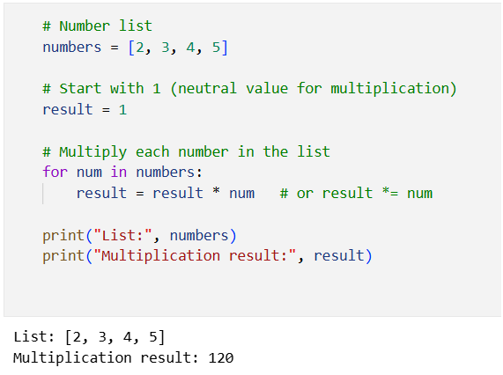

TASK NO 05:

DIVISION:
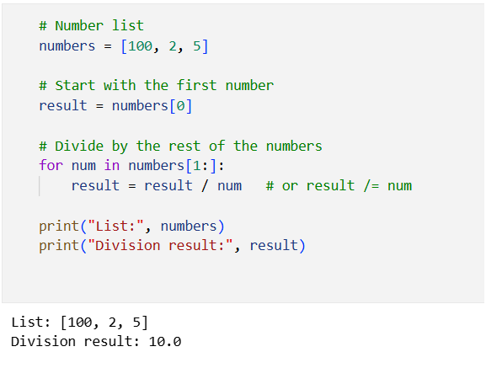

TASK NO 06:

EVEN AND ODD:
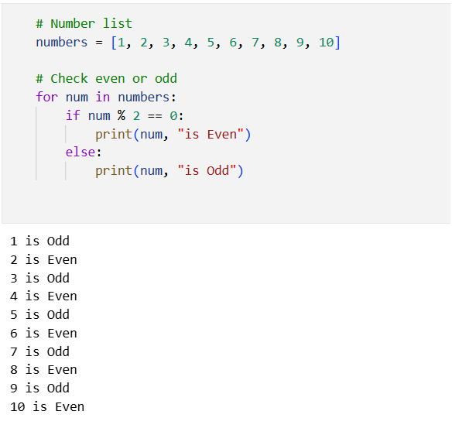

TASK NO 07:

MIN AND MAX:
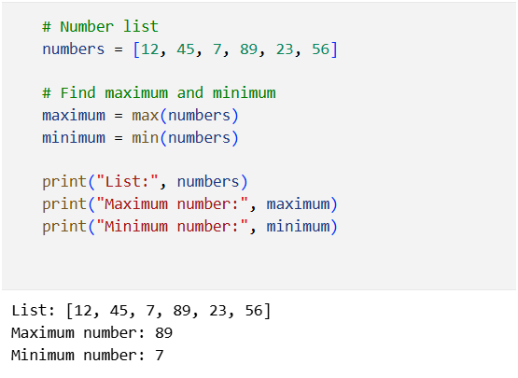

LAB NO 02

TASK NO 01:

TAKE STRING:
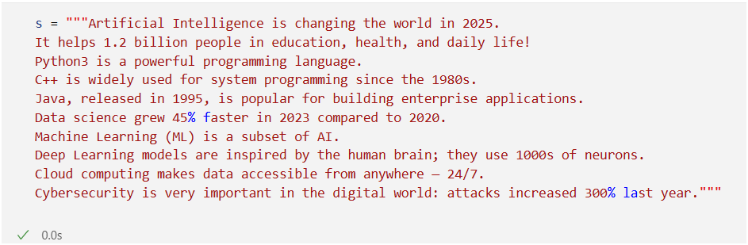
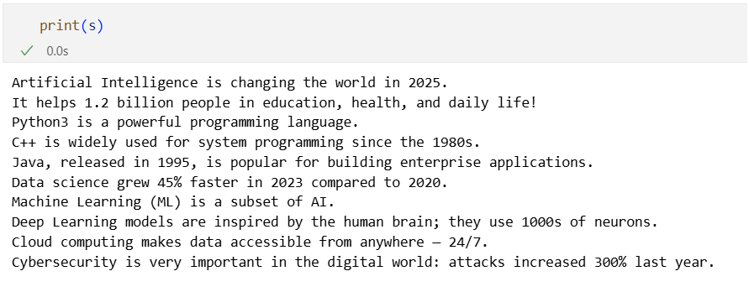

LOWERCASE:
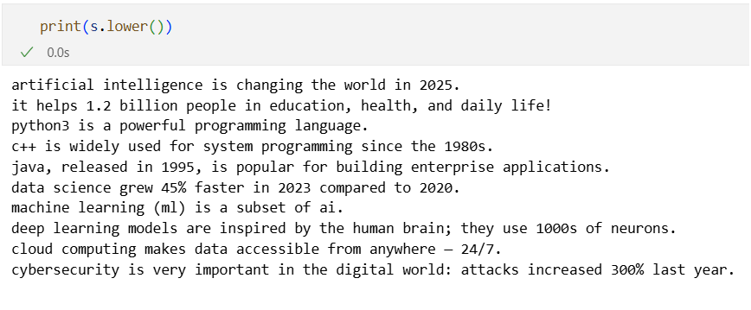

REMOVE NUMBERS:
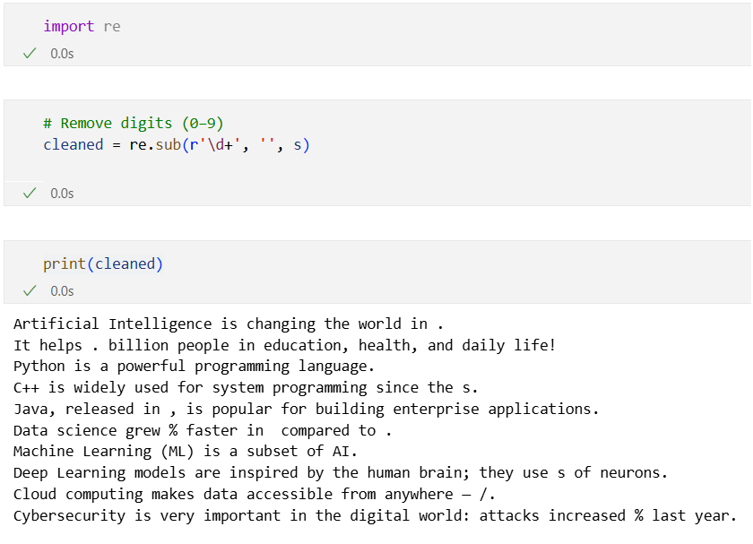

REMOVE PUNCTUATIONS:
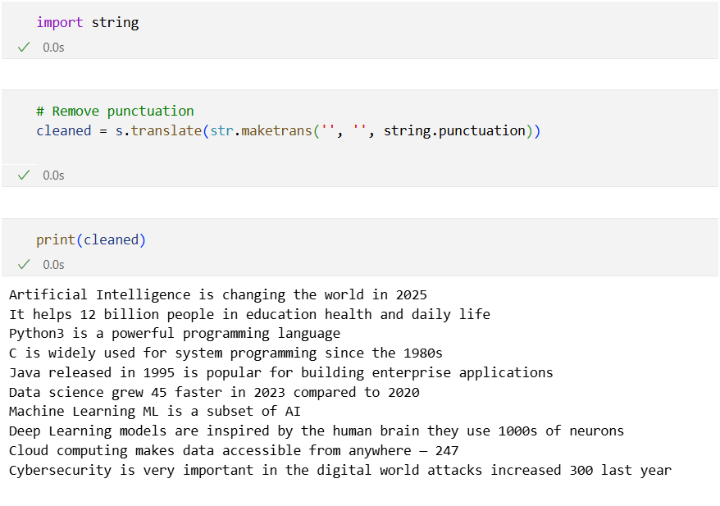

REMOVE STOPWORDS:
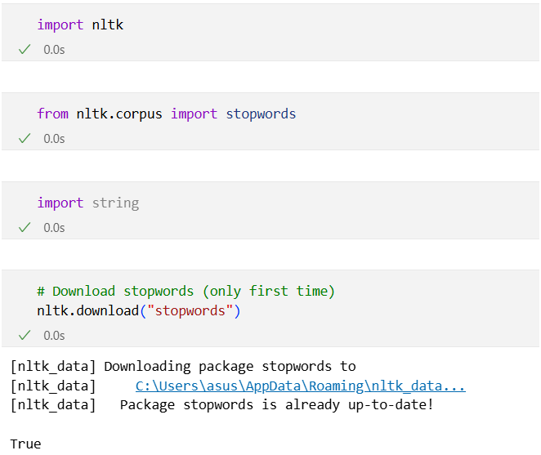
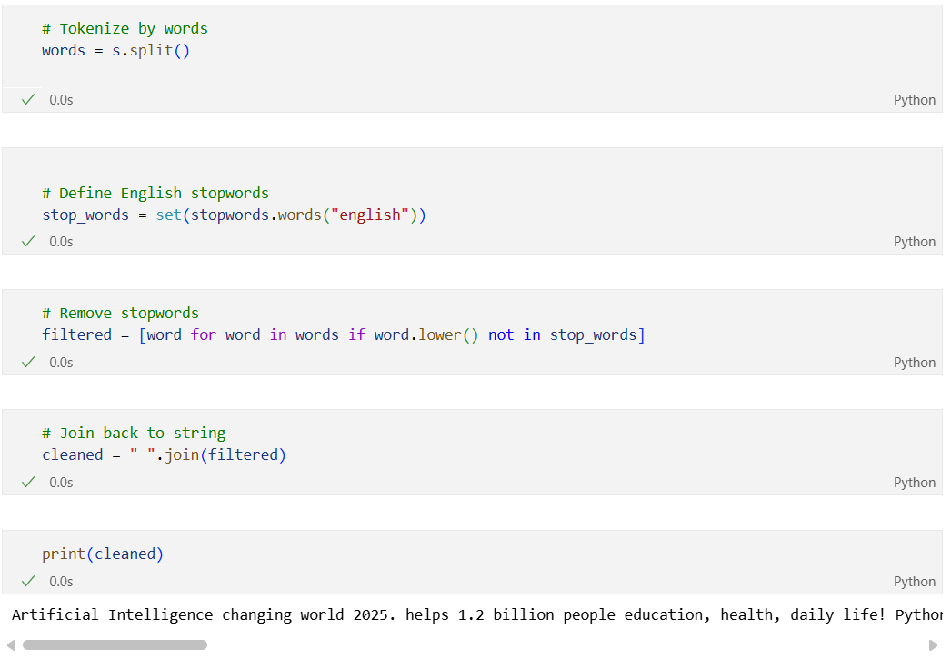

Regular Expressions

TASK NO 02:

re.findall():
Finds all matches and returns them in a list.
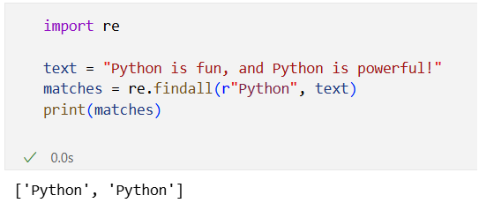

re.compile()
Compiles a regex pattern into a reusable object.
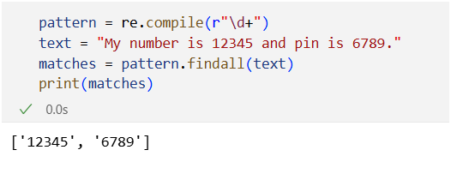

re.split()
Splits a string by regex pattern.
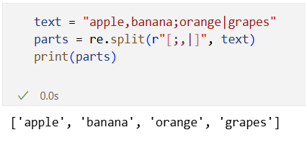

re.subn()
Replaces matches and returns a tuple (new_string, number_of_subs).
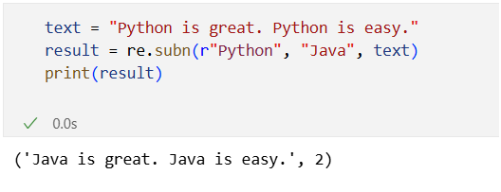

re.escape()
Escapes special regex characters so they are treated literally.
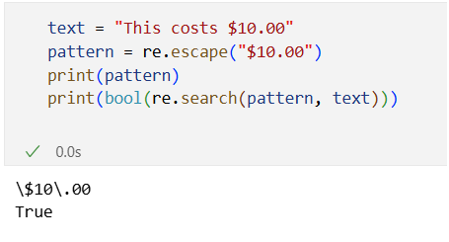

re.search()
Finds the first match of a pattern.
